The NHRC-7 is a bridging repeater controller, which can be configured for a variety of different applications. Some of the most common applications are detailed in this note.
This document is not intended to be used as a replacement to the NHRC-7 User Guide, it is meant to be used as a supplement to it. A NHRC-7 user should use the instructions in the NHRC-7 User Guide to program the CW IDs, change the default command prefixes, and make programming adjustments beyond what is provided by this application note.
These examples refer to NHRC-7 firmware version 1.2 and later. Old NHRC-7s can be upgraded to this new firmware for a nominal fee. Contact the factory for information.
CAUTION: The examples shown in this application note all rely on the factory default command prefixes. These are the same prefixes that are printed in the manuals. Leaving these prefixes at the factory defaults leaves your controller subject to mischief. After you have become comfortable with programming and using the controller, you must change the default command prefixes to secret values.
All examples shown in this application note assume that the “control operator prefix” is “00”, “load saved setup” is “03” and the “unlock code” is “07”. These are the as-shipped and factory-reset settings.

NHRC-7 System Architecture
The NHRC-7 connects simply between two radios, whether they are simplex or duplex.
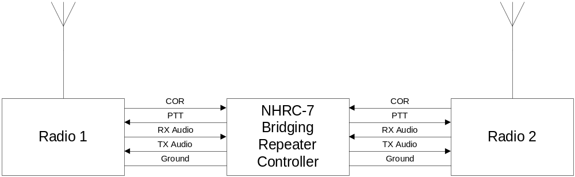
In addition to the signals shown, the NHRC-7 can accept a CTCSS indication (active high or low) and provide a “CTCSS encoder control” signal to the radio, allowing CTCSS to be utilized in the bridged system.
The NHRC-7 may be commanded by DTMF from either radio port, or from the dedicated control receiver port.

Architecture of the controller
The NHRC-7 provides a 2x2 crosspoint switch, which allows either receiver’s audio to be routed to either, or both, transmitters under control of the on-board microprocessor.
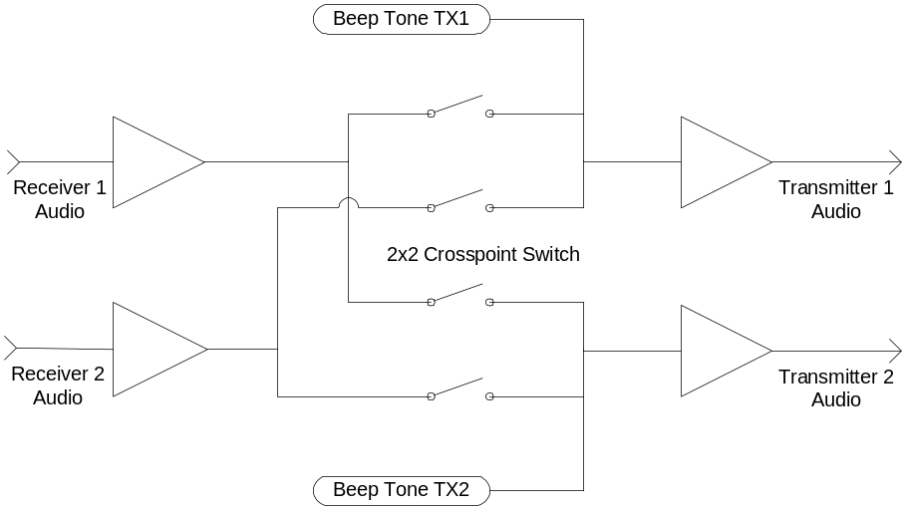
This diagram shows a simplified view of the NHRC-7 audio routing. Each receiver has jumper selectable de-emphasis, which allows discriminator audio to be used if the user desires. Each receiver has an input level control, and each transmitter has an output level control. In addition, the 1 to 2 and 2 to 1 audio paths have an additional “balance” control on them, which greatly simplify setup and alignment in the field.
Since the audio gating is under control of the microprocessor, unsquelched audio can be used, and receiver priority can also be specified.

NHRC-7 Example Configurations

About the configurations
The NHRC-7 configurations shown in this document represent some of the most popular usages reported by our customers. There are many other useful customizations possible beyond the example configurations shown here, the built in examples are designed to be useful right away and serve as a basis for your own customizations.

Using the configurations
The example configurations described in this application are the “factory reset” defaults for NHRC-7 saved setups number 1 through 4. To select one of the example configurations, send the “load saved setup” prefix followed by the number of the saved setup you want to load.
For example; to select the “repeater with a remote base” saved setup, you would send the following DTMF digits to the controller:
03 2
To load saved setup 2.
To make your current settings the power up default, you will need to send the unlock code to the controller, and then save setup #0, which is the power up setup.
Send the following DTMF command to the controller:
07
The controller should respond with OK in Morse code.
Now send the following DTMF to the controller:
*10
This will save the power up setup for the controller. The controller should send back “OK in Morse code.
Send the following DTMF to the controller to lock it=:
#
The controller should respond with OK in Morse code.

Programming Control Operator Switches
(Once again, all examples shown in this application note assume that the “control operator prefix” is “00”, and the “unlock code” is “07”. If you have changed your prefixes, use your codes instead.)
To set the value of a control operator switch, send the following DTMF digits to the controller through either radio or the control receiver audio input:
00<group-digit><item-digit><value>
In the example shown above, “00” is the control operator prefix, <group-digit> is the group number, one of 0 through 9, <item-digit> is the item number, one of 0 through 7, and the <value> is the value to set for the switch, 0 for off and 1 for on.
For example, to program group 4, switch 5 to 1 (which will set transmitter 1 as duplex) use the following command:
00451
The controller will respond with “ON” (--- -·) in Morse code when setting a switch on, and “OFF” (--- ··-· ··-·) in Morse code when setting a switch off.

Back-to-back simplex radios for bi-directional cross-band repeat
The NHRC-7 can be used to build an interoperability bridge using two inexpensive mobile radios as a bi-directional cross-band repeater. In this configuration, receiver 1’s audio is routed to transmitter 2, and receiver 2’s audio is routed to transmitter 1.
This is the factory default power-up configuration for NHRC-7s with firmware version 1.21 or newer. In addition, this configuration is stored in the factory default for saved setup number 1.
This table lists the Control Operator settings needed for setting up a NHRC-7 for a bi-directional cross-band repeat.
Group | Item | Setting | Description
0 | 0 | 1 | Receiver 1 Enable
0 | 6 | 0 | Receiver 1 into Transmitter 1 off/disabled
0 | 7 | 1 | Receiver 1 into Transmitter 2
2 | 0 | 1 | Receiver 2 Enable
2 | 6 | 1 | Receiver 2 into Transmitter 1
2 | 7 | 0 | Receiver 2 into Transmitter 2 off/disabled
4 | 0 | 1 | Transmitter 1 Transmit Enable
4 | 1 | 0 | Transmitter 1 Hang Time Disabled
4 | 5 | 0 | Transmitter 1 Duplex Disabled
4 | 6 | 0 | Transmitter 1 Receiver 1 Courtesy Tone Disabled
4 | 7 | 0 | Transmitter 1 Receiver 2 Courtesy Tone Disabled
5 | 0 | 1 | Transmitter 2 Transmit Enable
5 | 1 | 0 | Transmitter 2 Hang Time Disabled
5 | 5 | 0 | Transmitter 2 Duplex Disabled
5 | 6 | 0 | Transmitter 2 Receiver 1 Courtesy Tone Disabled
5 | 7 | 0 | Transmitter 2 Receiver 2 Courtesy Tone Disabled

Repeater with a Remote Base
Another popular use for the NHRC-7 is a repeater with a simplex or half-duplex remote base/link radio. In this configuration, Port 1 is used for a full-duplex repeater, and Port 2 is used for the remote base or link radio.
This configuration is provided as the factory default for saved setup number 2.
This table lists the Control Operator settings needed for setting up a NHRC-7 for the “Repeater with Remote Base” configuration.
Group | Item | Setting | Description
0 | 0 | 1 | Receiver 1 Enable
0 | 6 | 1 | Receiver 1 into Transmitter 1
0 | 7 | 1 | Receiver 1 into Transmitter 2
2 | 0 | 1 | Receiver 2 Enable
2 | 6 | 1 | Receiver 2 into Transmitter 1
2 | 7 | 0 | Receiver 2 into Transmitter 2 off/disabled
4 | 0 | 1 | Transmitter 1 Transmit Enable
4 | 1 | 1 | Transmitter 1 Hang Time Enable
4 | 5 | 1 | Transmitter 1 Duplex Enabled
5 | 0 | 1 | Transmitter 2 Transmit Enable
5 | 1 | 0 | Transmitter 2 Hang Time Disabled
5 | 5 | 0 | Transmitter 2 Duplex Disabled

Two Separate Repeaters
The NHRC-7 can control two separate repeaters, each with their own CW ID, simultaneously.
This configuration is provided as the factory default for saved setup 3.
The table below lists the Control Operator settings needed for setting up a NHRC-7 for the “Two Separate Repeaters” configuration.
Group | Item | Setting | Description
0 | 0 | 1 | Receiver 1 Enable
0 | 6 | 1 | Receiver 1 into Transmitter 1
0 | 7 | 0 | Receiver 1 into Transmitter 2 off/disabled
2 | 0 | 1 | Receiver 2 Enable
2 | 6 | 0 | Receiver 2 into Transmitter 1 off/disabled
2 | 7 | 1 | Receiver 2 into Transmitter 2
4 | 0 | 1 | Transmitter 1 Transmit Enable
4 | 1 | 1 | Transmitter 1 Hang Time Enable
4 | 5 | 1 | Transmitter 1 Duplex Enabled
5 | 0 | 1 | Transmitter 2 Transmit Enable
5 | 1 | 1 | Transmitter 2 Hang Time Enabled
5 | 5 | 1 | Transmitter 2 Duplex Enabled

Two Separate Repeaters, Linked
The NHRC-7 can control two separate repeaters, linked, each with their own CW ID, simultaneously.
This configuration is provided as the factory default for saved setup 4.
The table below lists the Control Operator settings needed for setting up a NHRC-7 for the “Two Separate Repeaters, Linked” configuration.
Group | Item | Setting | Description
0 | 0 | 1 | Receiver 1 Enable
0 | 6 | 1 | Receiver 1 into Transmitter 1
0 | 7 | 1 | Receiver 1 into Transmitter 2
2 | 0 | 1 | Receiver 2 Enable
2 | 6 | 1 | Receiver 2 into Transmitter 1
2 | 7 | 1 | Receiver 2 into Transmitter 2
4 | 0 | 1 | Transmitter 1 Transmit Enable
4 | 1 | 1 | Transmitter 1 Hang Time Enable
4 | 5 | 1 | Transmitter 1 Duplex Enabled
5 | 0 | 1 | Transmitter 2 Transmit Enable
5 | 1 | 1 | Transmitter 2 Hang Time Enabled
5 | 5 | 1 | Transmitter 2 Duplex Enabled

Full-Duplex Cross-band Bridge
The NHRC-7 can be used to build a full-duplex cross band bridge. Extreme care should be used in this configuration, as it is possible to cause a “lock-up” condition if two repeaters are linked in full duplex. In general, a full duplex bridge should not be built between two repeater systems. However, using a full duplex link and a full duplex radio is possible, and desirable should the range of an existing repeater system need to be extended. In this case, the “repeat” path for the audio must be at the far end. The NHRC-7 can be used as a repeater extender in this mode.
This table lists the Control Operator settings needed for setting up a NHRC-7 for a bi-directional cross-band full duplex configuration. This is very similar to the bi-directional cross band repeat configuration, except the transmitters are set for duplex mode.
Group | Item | Setting | Description
0 | 0 | 1 | Receiver 1 Enable
0 | 6 | 0 | Receiver 1 into Transmitter 1 off/disabled
0 | 7 | 1 | Receiver 1 into Transmitter 2
2 | 0 | 1 | Receiver 2 Enable
2 | 6 | 1 | Receiver 2 into Transmitter 1
2 | 7 | 0 | Receiver 2 into Transmitter 2 off/disabled
4 | 0 | 1 | Transmitter 1 Transmit Enable
4 | 1 | 0 | Transmitter 1 Hang Time Disabled
4 | 5 | 1 | Transmitter 1 Duplex Enabled
5 | 0 | 1 | Transmitter 2 Transmit Enable
5 | 1 | 0 | Transmitter 2 Hang Time Disabled
5 | 5 | 1 | Transmitter 2 Duplex Enabled

You can start with the settings in saved setup 1, and then adjust to include what is shown above.
Once again, extreme care must be taken in using this configuration to prevent “lock-up” and “howling” conditions.

Notes on Using Simplex and Mobile Radios
The NHRC-7 factory-default power on condition is for each port to be configured for “duplex off.” This is done deliberately, because were the port configured for duplex and enabled for repeat, the port would be unusable for control with a simplex radio. This issue is caused by the simple fact that the simplex radio is no longer able to receive when it has its PTT asserted, and if the radio is configured for duplex that is exactly what will happen.
Simplex radios (those that cannot receive while transmitting) should always have the transmitter duplex enable turned off (0). This is control operator group 4, item 5 for radio 1, and group 5, item 5 for radio 2.

Receiver Priority Modes
When two ports are linked, and they both receive, the selected transmitter gets a mix of audio from both ports. The NHRC-7 has two priority mode settings that allow the system configuration to choose mix, port 1, port 2, or “first port” modes.
Receiver 1 has Priority | Group 1, Item 5 | 0 | 1 | 0 | 1
Receiver 2 has Priority | Group 3, Item 5 | 0 | 0 | 1 | 1
What you hear |  | Mix | Receiver 1 | Receiver 2 | First Active

Using External Stimulus to Select Saved Setups
The NHRC-7 has support to allows external digital inputs to select controller saved setups.. This allows the operating mode of the controller to be set based on a signals on the digital inputs of the controller. This feature can be used for a variety of purposes, including “link on-off” toggle switch, linking control based on use of an alternate CTCSS tone, etc.
This feature is enabled by setting control operator switch group 1, item 3 to on (1). When the “Load Setup on CTSEL 1/2/3 low” feature is enabled, grounding CTSEL1 will force the controller to load saved setup 1, grounding CTSEL2 will force the controller to load saved setup 2, and grounding CTSEL3 will force the controller to load saved setup 3. In the event that more than one of CTSEL1/CTSEL2/CTSEL3 is low, the lower numbered CTSEL is used.

Linked/Unlinked Control by received CTCSS tone
You can use different CTCSS tones to select controller linking state. This allows “talk-through” the local repeater with one tone, “talk-through” the link using the other tone.
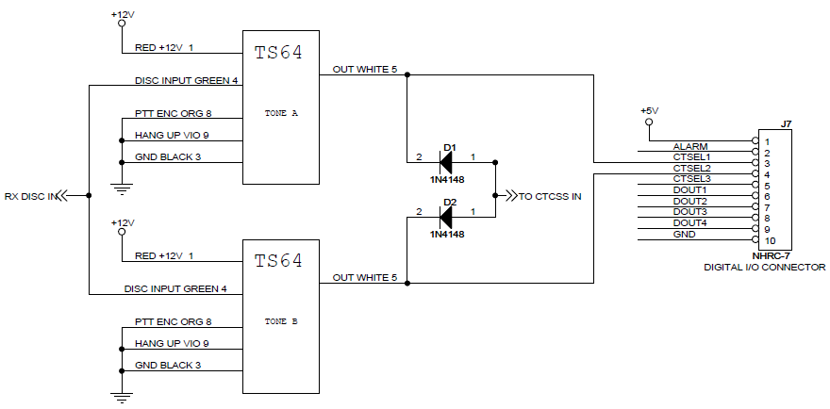
In the schematic shown above, one CTCSS tone selects saved setup 1, and the other tone selects saved setup 2. Saved setup 1is set up for a repeater on port 1, with the link to port 2 turned off, and saved setup 2 is set up for a repeater on port 1, and a remote base link on port 2 enabled. Users the first tone will only transmit through the repeater, users with the second tone will activate the remote base and transmit through it as well. This configuration allows a user with a mobile radio to select local repeat or remote base by simply changing the channel on their radio; one channel has the first tone encoded, and the next channel has the other tone encoded.

Linked/Unlinked Control based on contact closure inputs
Pushbuttons, toggle switches, or even a rotary switch can be used to select the controller linking state. This allows untrained personnel to adjust the controller operation (including linked/unlinked) based on simply moving a switch.
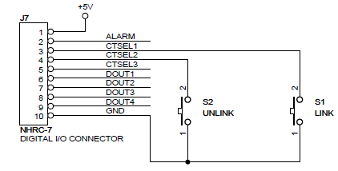
In the schematic shown above, emergency response crew can simply push the S1 “LINK” or S2 “UNLINK” pushbuttons to change the linked state of the controller

Last Loaded Saved Setup Number Selects Courtesy Tone mode
The “Change State on CTSEL 1/2/3” feature works well with the “Saved State Number Selects Courtesy Tone” mode, which is activated by setting control operator switch group 3, item 3 to on (1). When this feature is enabled, the controller plays a different courtesy tone based on the last saved state that was selected.
The courtesy tones can be programmed to beeps or Morse code letters and numbers to indicate to remote users the current state of the controller. Some interesting or useful courtesy tones are the letters, E, I, S, H and 5 for one dit, two dits, three dits, four dits, and 5 dits. High, low, high/low, low/high tones can also be programmed. The courtesy tone serves as telemetry to notify the user which state the controller is in.

Alarm Input
The NHRC-7 supports an optional Alarm feature. If the alarm feature is activated in software, pulling the ALARM\ signal to ground will activate the alarm tone, which will play over the air once a minute until reset.
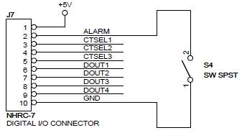
The ALARM input has a weak pull-up resistor, a simple contact closure to ground can activate the alarm.

CTCSS Encoder Control
The NHRC-7 can control CTCSS encoders on transmitters to provide such features as “tone on receive” and “subtone muting” to help suppress telemetry and squelch crash playing over links.
Tone on receive (NHRC-7 User Guide sections 4.1, 4.3) enables the CTCSS encoder while the specified receivers are active. This feature can be used to allow users to choose not to hear the repeater telemetry, or to encode a tone when the remote base receiver is active. “Subtone Muting” turns off the CTCSS encoder ¼ second before the transmitter, to help to control squelch crashes. See section 4.7 of the NHRC-7 manual for more information about CTCSS encoder control.
The schematic below shows how a NHRC-7 can be used to control two of the popular TS-64 CTCSS encoders.
